
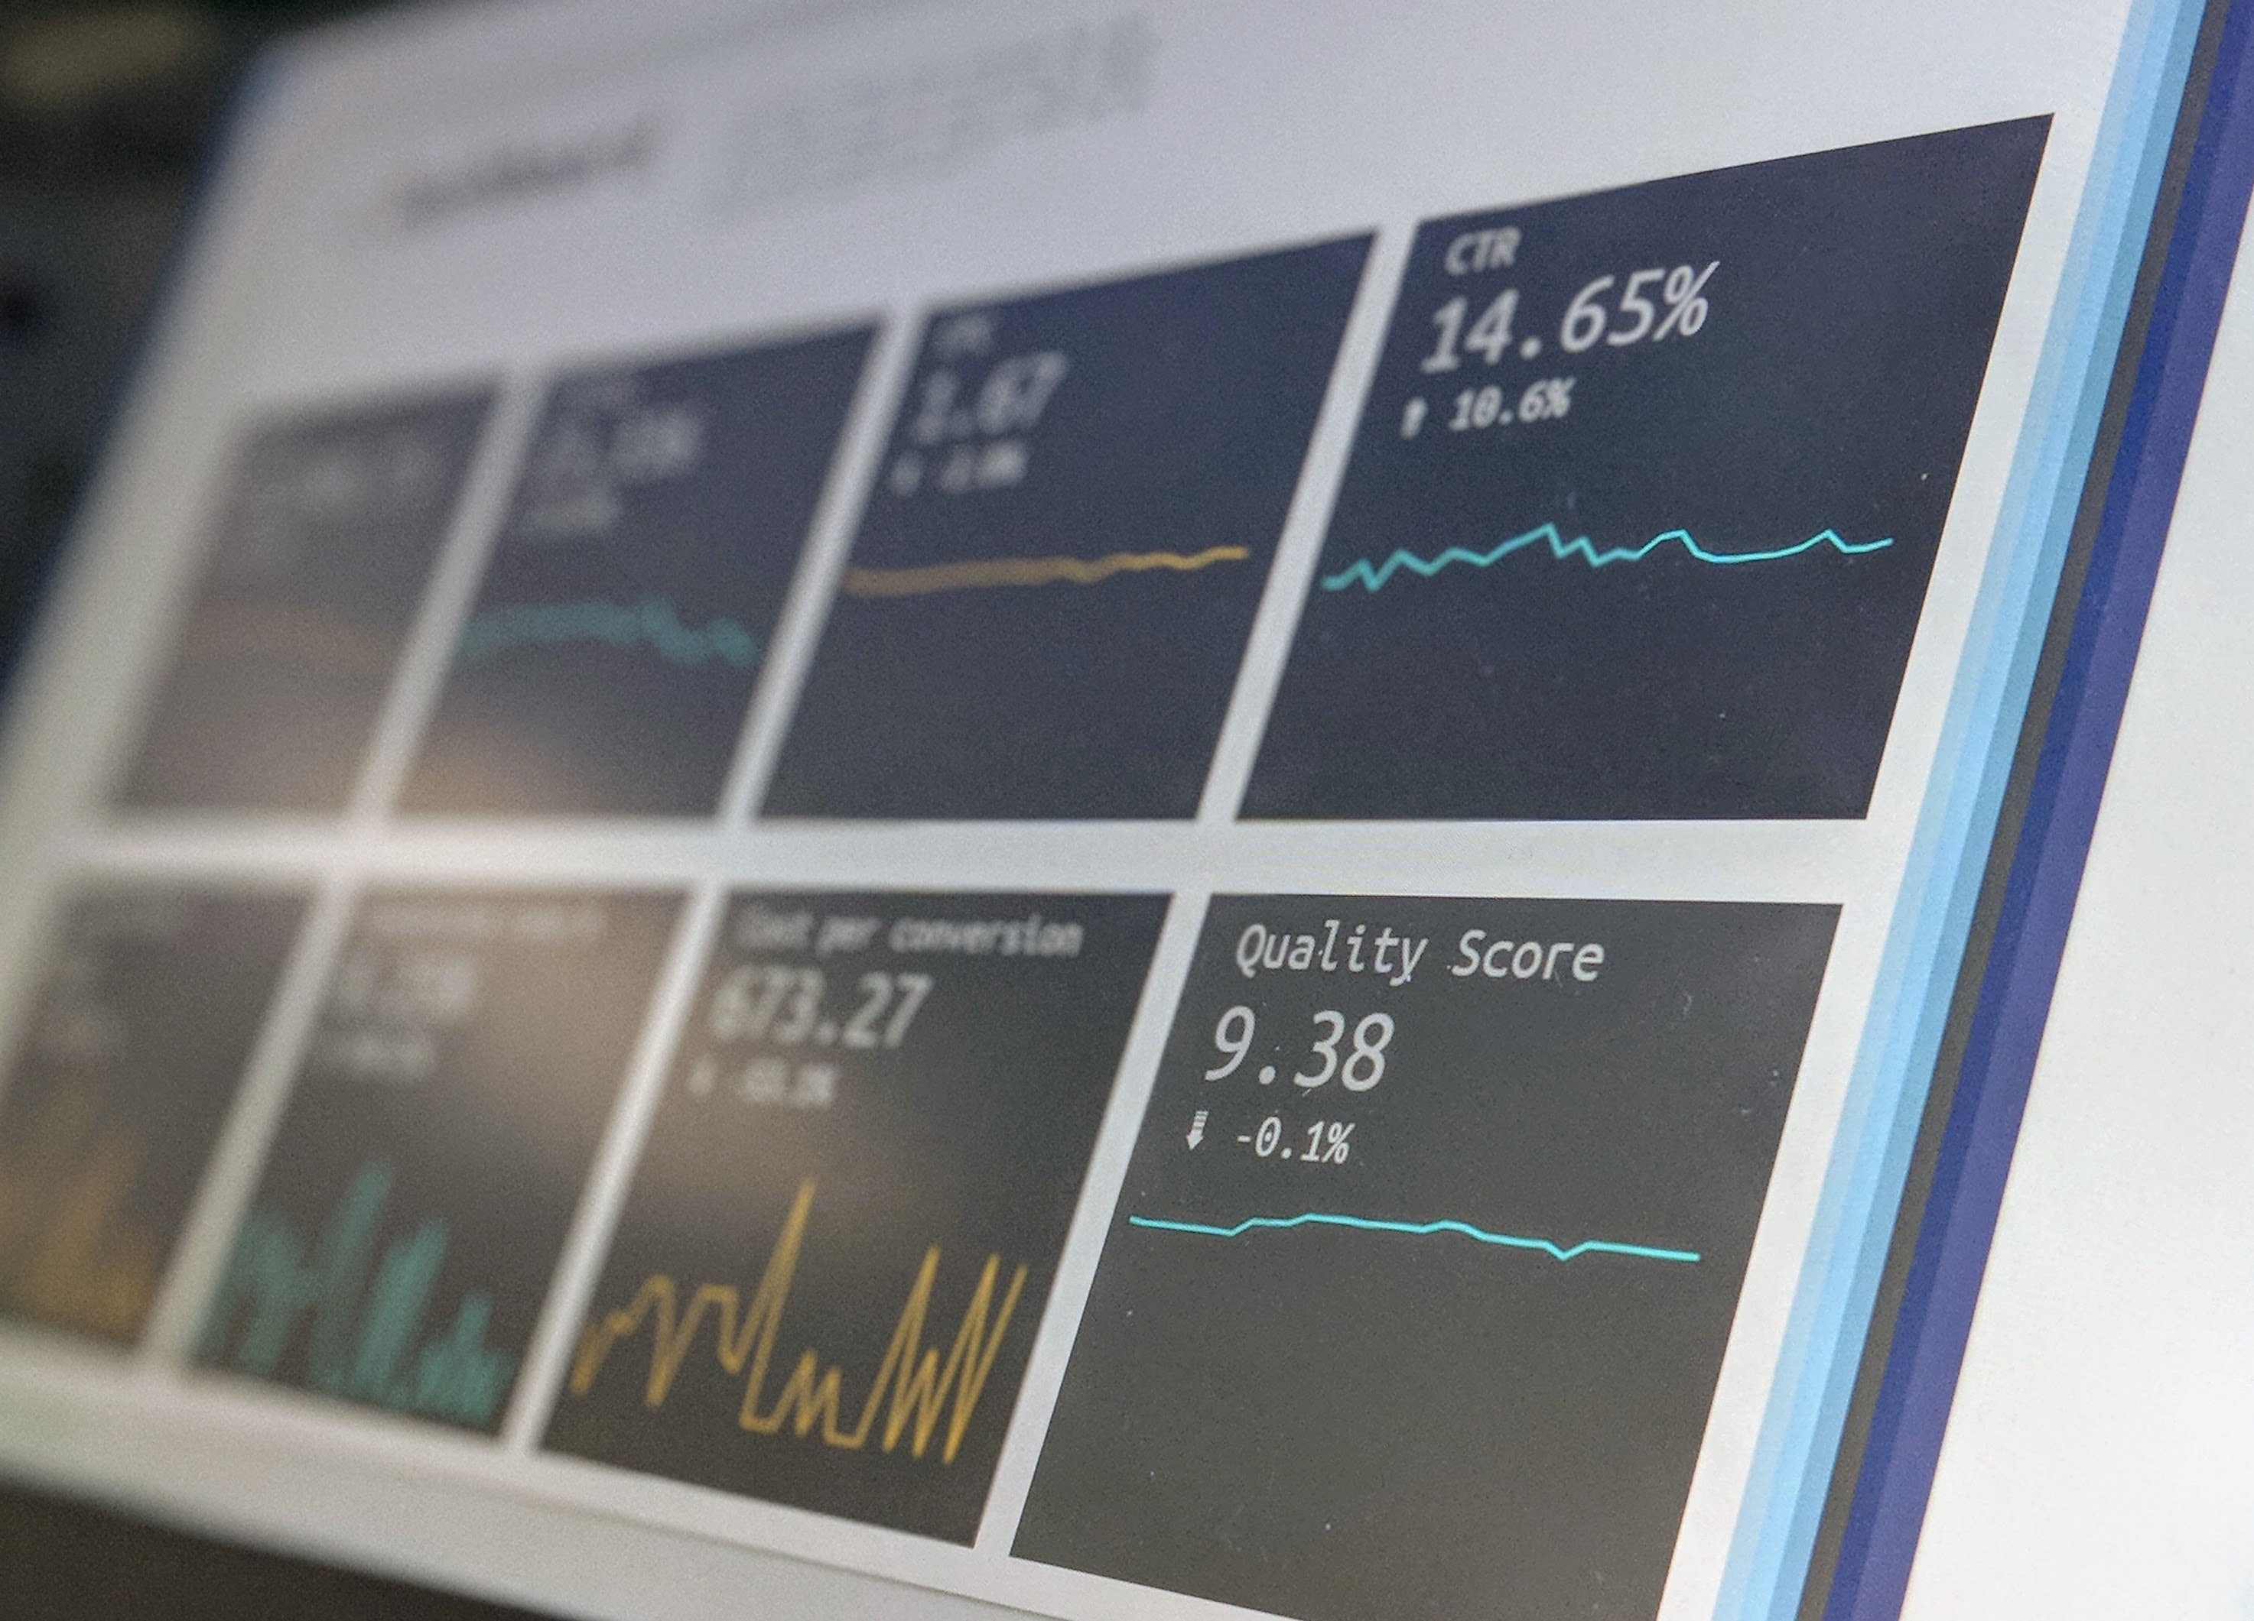

FINANCIAL CRIME COMPLIANCE
ISSA Questionnaire (FCC DDQ)
Version to be completed by Entities that have completed one of the current versions of the Wolfsberg Anti-Money Laundering Questionnaires (CBDDQ or FCCQ).

December 2025


FINANCIAL CRIME COMPLIANCE
ISSA Questionnaire (FCC DDQ)
Version to be completed by Entities that have completed one of the current versions of the Wolfsberg Anti-Money Laundering Questionnaires (CBDDQ or FCCQ).

2023
September 2021
DISCLAIMER
It is ISSA’s intention that this questionnaire should be updated periodically. This document does not represent professional or legal advice and will be subject to changes in regulation, interpretation, or practice. None of the products, services, practices or standards referenced or set out in this questionnaire are intended to be prescriptive for market participants. Therefore, they should not be viewed as express or implied required market practice. Instead, they are meant to be informative reference points which may help market participants manage the challenges in today's Securities Services environment. Neither ISSA nor the members of ISSA's Working Group warrant the accuracy or completeness of the information or analysis contained in this report.
ISSA does not warrant the accuracy or completeness of the information or analysis contained in this paper.

EXECUTIVE SUMMARY
Introduction
The International Securities Services Association (ISSA) is a global association that supports the Securities Services industry. ISSA’s members include Central Securities Depositories (CSDs), custodians, technology companies and other firms who are actively involved in all aspects of the Securities Services value chain. By connecting its members and facilitating collaboration, ISSA provides the leadership necessary to drive change in the Securities Services industry. The focus is on finding progressive solutions to reduce risk and improve efficiency and effectiveness – from issuer through to investor – as well as on providing broader thought-leadership to help shape the future of the industry.
Background
In August 2015, the ISSA Financial Crime Compliance Working Group (FCC WG) released 17 Principles for the Securities Services industry to adopt. These principles aimed to address the critical challenges posed by financial crime, particularly in environments where omnibus and commingled account structures are utilized. Along with the FCC Principles, the WG also created a Financial Crime Compliance Due Diligence Questionnaire (FCC DDQ), known as the ISSA Questionnaire, to complement the FCC Principles.
The WG’s business-as-usual scope includes ongoing reviews of the FCC Principles and the related ISSA Questionnaire to ensure that they continue to be relevant as the market changes and evolves.
ISSA Questionnaire
Currently there is no single financial services “industry-wide” financial crime due diligence approach that caters for all sectors of the financial services industry. For the Securities Services industry, the following questionnaires have been developed (see diagram below for further details):
- Wolfsberg Questionnaires
The Wolfsberg Questionnaires cover the cash sector and any cash that is payment-related
- ISSA Questionnaire
The ISSA questionnaire provides a similar framework for the securities sector, covering areas not included in the Wolfsberg questionnaires. The ISSA questionnaire is therefore not intended to replace the Wolfsberg Questionnaires; but complement them
Before completing the ISSA Questionnaire, the Entity should review the Appendices, which contain useful information to assist in completing this document:
- Explanatory Notes offers guidance notes on completing the different sections
- A Glossary of Terms provides definitions of key words

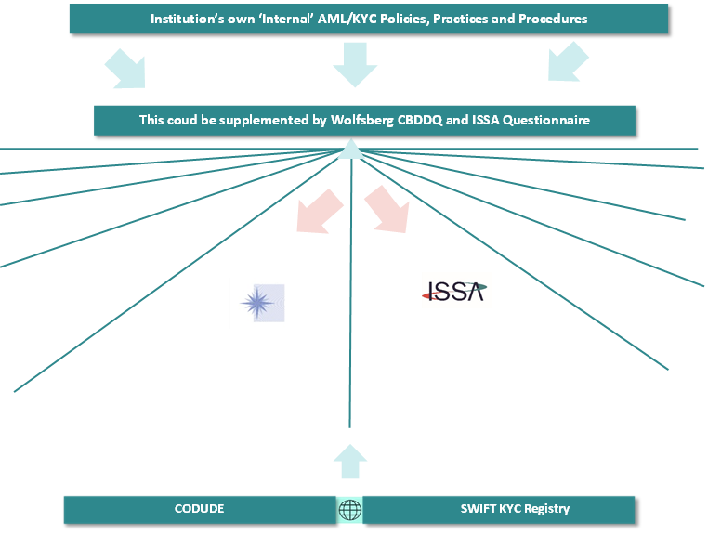
ISSA Questionnaire
The ISSA Questionnaire and supporting FCC Principles position the uniqueness of the Securities Services industry and provide a common client due diligence framework for global relationships throughout the Securities Services value chain

Securities

Cash
the
Wolfsberg
Group

Benefits of the ISSA Questionnaire
Used on its own, or in tandem with an institution’s own internal DDQ, the ISSA Questionnaire will enable a Securities Services Provider to have a comprehensive Client due diligence framework adequately covering its Securities Services business The benefits include:
- providing Securities Services Providers with a tool to assist them in performing due diligence on Entities addressing the characteristics of cross-border securities relationships
- enabling Securities Services Providers to assess the extent to which any given account relationship complies with the ISSA Financial Crime Compliance Principles, in accordance with their own risk-based approach
- providing Entities with the information that their Securities Services Providers' due diligence framework is likely to require and to support the Entity in defining its own due diligence objectives, thereby creating awareness and promoting common standards within the securities industry
Target Audience
This document should be completed by the following:
- Securities Services Providers who offer securities settlement, custody, funds distribution or similar services and intend to open (for prospects), or already have opened (for existing Clients), accounts at their Securities Services Provider(s) to deposit their own or Client assets
- The FCC Principles do not address the conduct of the issuer or its agents and therefore the ISSA Questionnaire does not need to be completed by Transfer Agents or Fund Administrators

ENTITY IDENTIFICATION

Company Information
Registered Company Name
Building/ PO Box |  | Street
City |  | Postcode / Zip
State (if required) |  | Country
BIC 8 (if allocated) |  | LEI (if allocated)
If any, please indicate Branches not covered by this Questionnaire

Contact Information (Questionnaire completed by)
First Name |  | Last Name
Title |  | Job Role
e-Mail |  | Telephone

Authorized Representative(s)

Date

FCC QUESTIONS

Entity’s Compliance Policies and Framework

Has the Entity adopted all necessary and appropriate AML/CFT and sanctions compliance policies and procedures, supported by appropriate compliance controls, which cover the Entity’s securities settlement, custody, funds distribution or similar services?
Yes ☒ No ☐ Partially ☐
If “No” or “Partially”: Mandatory clarification
If “Yes”: Optional clarification

Does the Entity take necessary steps to determine that the Ultimate Assets Beneficial Ownership deposited in an account has been adequately identified or, alternatively, does the Entity have the adequate contractual arrangements with, or written representations from, all its Clients to require this?
Yes ☐ No ☐ Partially ☐
If “No” or “Partially”: Mandatory clarification
If “Yes”: Optional clarification

Entity’s Due Diligence Programme

Does the Entity, as part of its initial and ongoing Client due diligence efforts, consider the following factors?

International best practices and guidance, including the ones specific to the Securities Services industry, such as the FATF ‘Risk-based Approach Guidance for the Securities Sector’
Yes ☐ No ☐ Partially ☐
If “No” or “Partially”: Mandatory clarification
If “Yes”: Optional clarification

Country/geography risks considered in the Client risk assessment
Yes ☐ No ☐ Partially ☐
If “No” or “Partially”: Mandatory clarification
If “Yes”: Optional clarification

Risk Factors linked to assets the Entity would deposit with its Securities Services Provider(s)
Yes ☐ No ☐ Partially ☐
If «No» or «Partially»: Mandatory clarification
If «Yes»: Optional clarification

As part of the Entity’s initial and ongoing due diligence, does the Entity screen the following items against lists of Sanctioned Parties?

Client Identification Data (e.g. Shareholder data)
Yes ☐ No ☐ Partially ☐
If “No” or “Partially”: Mandatory clarification
If “Yes”: Optional clarification

Ultimate Assets Beneficial Owner data, to the extent that the data is in its possession, in the Entity’s operating systems and databases (The targeted data for Ultimate Assets Beneficial Owners includes, but is not limited to, tax certificates or disclosure requests)
Yes ☐ No ☐ Partially ☐
If “No” or “Partially”: Mandatory clarification
If “Yes”: Optional clarification

Intermediary data, to the extent that the data is in its possession, as in the Entity’s operating systems and databases (e.g. clients of your clients acting as Sub-custodians)
Yes ☐ No ☐ Partially ☐
If “No” or “Partially”: Mandatory clarification
If “Yes”: Optional clarification

Parties authorized to operate Clients’ accounts (e.g. agent, attorney or other person appointed by the Client or liquidator, administrator or regulatory authority) to send instructions and/or receive reporting on its behalf)
Yes ☐ No ☐ Partially ☐
If “No” or “Partially”: Mandatory clarification
If “Yes”: Optional clarification

Information included in applicable securities transactions fields (The targeted data includes, but is not limited to, the names of Intermediaries or the Ultimate Assets Beneficial Owners of a security as mentioned in a transactional field / component (such as MT 15002, ISO 20022 or other proprietary standard)
Yes ☐ No ☐ Partially ☐
If “No” or “Partially”: Mandatory clarification
If “Yes”: Optional clarification

Information included in applicable cash transactions linked to its securities business (The target data includes, but is not limited to, free text fields in SWIFT transactions)
Yes ☐ No ☐ Partially ☐
If “No” or “Partially”: Mandatory clarification
If “Yes”: Optional clarification

Securities related information (This information includes, but is not limited to, ISIN, issuer name, etc.)
Yes ☐ No ☐ Partially ☐
If “No” or “Partially”: Mandatory clarification
If “Yes”: Optional clarification

Does the Entity confirm that it screens all relevant, available information against the following Sanctions Issuing Authorities?
Sanctions Issuing Authority | Yes | No | Partially
UN | ☐ | ☐ | ☐
OFAC | ☐ | ☐ | ☐
OFSI | ☐ | ☐ | ☐
EU | ☐ | ☐ | ☐
Other G7 Member Countries | ☐ | ☐ | ☐
Relevant Domestic Authorities | ☐ | ☐ | ☐
For each “No” or “Partially”: Mandatory clarification
For each “Yes”: Optional clarification

Entity’s Transaction Monitoring System

Does the Entity have a monitoring programme reasonably designed to identify unusual and potentially suspicious activity that is covering the securities and/or fund related services that it provides to its Clients?
Yes ☐ No ☐ Partially ☐
If “No” or “Partially”: Mandatory clarification
If “Yes”: Optional clarification

Does the Entity have controls and/or appropriate arrangements in place to ensure that its cash accounts held with its Securities Services Provider(s) are not used to facilitate any unauthorized non-securities related transactions or an activity that does not fall within the scope of the services offered?
Yes ☐ No ☐ Partially ☐
If “No” or “Partially”: Mandatory clarification
If “Yes”: Optional clarification

Does the Entity allow external access by Third Parties to securities and /or cash accounts held by the Entity at the Securities Services Provider and does it confirm that it undertakes appropriate due diligence and controls on these Third Parties in line with this Questionnaire?
Yes ☐ No ☐ Partially ☐
If “No”: Optional clarification
If “Yes” ” or “Partially”: Mandatory clarification
2.3.4 Does the Entity use, or intend to use, an account to deposit, settle or provide custody services for digital assets (including, but not limited to, cryptocurrencies, stablecoins and tokenized securities)?
Yes ☐ No ☐
If “Yes” please describe the controls and screening processes in place to manage the specific risks associated with digital assets:

If “Yes” please detail the processes for validating transactions before execution, including verifying recipient addresses:

Entity’s Assets Sub-deposited with its Securities Services Provider(s)

Does the Entity have the following policies and procedures in place to ensure exclusion, blockage or monitoring of restrictions applicable to assets deposited with its Securities Services Provider(s) that are owned or under the control of Sanctioned Parties or any other measures taken to comply with applicable sanctions regulations?

Systematically exclude and/or block, or ensure that its Clients can exclude and/or block, assets deposited with its Securities Services Provider(s) that are owned or under the control of a Sanctioned Party
Yes ☐ No ☐ To the extent permitted by law ☐
If “No” or “To the extent permitted by law”: Mandatory clarification
If “Yes”: Optional clarification

Block or restrict the settlement of assets owned or under the control of a Sanctioned Party
Yes ☐ No ☐ To the extent permitted by law ☐
If “No” or “To the extent permitted by law”: Mandatory clarification
If “Yes”: Optional clarification

Does the Entity have policies and procedures in place to ensure that it monitors and limits its activities, in relation to Sanctioned Parties, consistent with the requirements of the Sanctions Issuing Authorities listed in this Questionnaire including, when appropriate, notifying the Securities Services Provider and / or segregating assets ultimately owned by Sanctioned Parties in the books of the Securities Services Provider?
Yes ☐ No ☐ To the extent permitted by law ☐
If “No” or “To the extent permitted by law”: Mandatory clarification
If “Yes”: Optional clarification

Does the Entity have policies and procedures in place to ensure that it monitors and limits its activities, in relation to Impacted Parties, consistent with the requirements of the Sanctions Issuing Authorities listed in this Questionnaire?
Yes ☐ No ☐ To the extent permitted by law ☐
If “No” “To the extent permitted by law”: Mandatory clarification
If “Yes”: Optional clarification

Does the Entity have policies and procedures in place to notify its Securities Services Provider(s) as soon as it is aware that an asset it intends to deposit, or has deposited, with its Securities Services Provider(s) is ultimately owned by a Sanctioned Party and/ or Impacted Party?
Yes ☐ No ☐ To the extent permitted by law or
agreed contractually with its Securities Services Provider(s) ☐
If “No” or “To the extent permitted by law or agreed contractually with its Securities Services Provider(s)”: Mandatory clarification
If “Yes”: Optional clarification

Does the Entity have the necessary arrangements in place requiring it to be notified by its Clients should an asset it has deposited with its Securities Services Provider(s) be ultimately owned by a Sanctioned Party and/ or Impacted Party?
Yes ☐ No ☐ To the extent permitted by law ☐
If “No” “To the extent permitted by law”: Mandatory clarification
If “Yes”: Optional clarification

In practice, does the Entity intend to deposit, or has it already deposited with its Securities Services Provider(s), any asset ultimately owned or issued by a Sanctioned Party and/ or Impacted Party?
Yes ☐ No ☐
If “Yes” please complete the following question:

Has the Entity notified its Securities Services Provider(s) about any asset ultimately owned or issued by a Sanctioned Party and / or Impacted Party?
Yes ☐ No ☐ To the extent permitted by law or
agreed contractually with its Securities Services Provider(s) ☐
If “No” or “To the extent permitted by law or agreed contractually with its Securities Services Provider(s)”: Mandatory clarification
If “Yes”: Optional clarification

Omnibus and Commingled Accounts

Has the Entity opened, or intends to open, Omnibus or other Commingled Accounts with its Securities Services Provider(s)?
Yes ☐ No ☐
If “Yes” please complete the following two questions:

Does the Entity take necessary steps to determine that the Ultimate Assets Beneficial Ownership deposited in Omnibus form has been adequately identified or, alternatively, does the Entity have the adequate contractual arrangements with, or written representations from, all its Clients to require this?
Yes ☐ No ☐ Partially ☐
If “No” or “Partially”: Mandatory clarification
If “Yes”: Optional clarification

Does the Entity have procedures in place to avoid any misuse of its Omnibus or other Commingled Accounts to disguise the true ownership of assets held with its Securities Services Provider(s)?
Yes ☐ No ☐ Partially ☐
If “No” or “Partially”: Mandatory clarification
If “Yes”: Optional clarification

Entity’s Clients acting as Sub-Custodians

Does the Entity authorize its Clients to sub-deposit in its accounts third-party Client assets?
Yes ☐ No ☐
If “Yes” please complete the following two questions:

Does the Entity’s policies and procedures require that Clients sub-depositing assets on behalf of third-party Clients are adequately authorized to deal with Client assets, including suitable AML/CFT and Client assets protection regulation?
Yes ☐ No ☐ Partially ☐
If “No” or “Partially”: Mandatory clarification
If “Yes”: Optional clarification

Does the Entity’s policies and procedures require its own Clients to disclose the identity of holders of Segregated Client Accounts they intend to open with the Entity?
Yes ☐ No ☐ Partially ☐
If “No” or “Partially”: Mandatory clarification
If “Yes”: Optional clarification



ISSA Questionnaire (FCC DDQ)

Appendices
Appendix 1: Explanatory Notes
These explanatory notes are designed to assist in the completion of the ISSA questionnaire. Additional information about the ISSA Financial Crime Compliance Principles can also be found here or on the ISSA website (www.issanet.org) in the Financial Crime Compliance Working Group section.

Securities Services Value Chain
Below is a diagram that reflects the different roles in the Securities Services value chain. This shows how the different players interact and should be a useful aid to illustrate who the Entity and Securities Services Provider is throughout the value chain.
The Securities Services components of the lifecycle comprise the functions that are highlighted in green in the illustration below. These functions are trade capture, clearing, settlement and safekeeping and administration. There are also additional components of the asset lifecycle - highlighted in grey in the illustration below. These are connected and provide information and support that are needed for the Securities Services components to operate but are not, themselves, Securities Services functions.

Naming Conventions
The diagram below helps to illustrate the different roles in the Securities Services value chain. The naming convention in the ISSA Questionnaire is highlighted for ease of use.

Financial Institution
(e.g. Sub- Custodian)
Client
(e.g. Global Custodian)
Ultimate Assets Beneficial Owner
Securities Services Provider
Entity
Intermediary
End Buyer/End Seller
(Joe Bloggs)
Roles in the Securities Services Value Chain
How they are called in the ISSA Questionnaire
Client of the Client
(e.g. Broker Dealer)
Has opened an account with the Financial Institution
Has opened an account with the Client
Has opened an account with the Client of the Client

Structure of the ISSA Questionnaire
The ISSA questionnaire is split into two parts:
- Part 1: Entity Identification
- Part 2: FCC Questions
Part 1: Entity Identification
This part is to be completed and signed by the Entity that intends to contract, or is legally contracting, with its Securities Services Provider(s) for the purpose of providing securities settlement, custody, funds distribution or similar services. This section applies to the consumer / provider account and service relationships inherent throughout the custody value chain.
The table below serves as a highly simplified illustration:
Securities Services Provider | Entity
(I)CSD | Sub-Custodian
Sub-Custodian | Global Custodian
Sub-Custodian | Broker Dealer
Sub-Custodian | Bank / FI
Global Custodian | Asset Manager
Asset Manager | Investor

Part 2: FCC Questions
This part comprises a series of Financial Crime Compliance questions. The questions look to ascertain the nature and purpose of the account requested to be opened / currently serviced.
The questions in this section must be answered by the Entity irrespective of whether:
- the Entity is depositing its Clients’ assets with its Securities Services Provider(s) or also its Clients’ third-party Client assets
- the assets are held in a Segregated, Omnibus or Commingled Account structure
The themes covered are:
Section 1: Entity’s Compliance Policies and Framework
Section 2: Entity’s Due Diligence Programme
Section 3: Entity’s Transaction Monitoring System
Section 4: Entity’s Assets Sub-deposited with its Securities Services Provider(s)
Section 5: Omnibus and Client Commingled Accounts
Section 6: Entity’s Clients acting as Sub-Securities Services Providers

Completing the ISSA Questionnaire
The ISSA Questionnaire can either be completed on a standalone basis or the questions may be incorporated into a Securities Services Provider’s own internal systems. The ISSA Questionnaire is also available on the SWIFT KYC Registry and on Myriad’s CODUDE platform.

Please note the following points before completing the ISSA Questionnaire:
- In this document, the ‘Entity’ (as defined in the Glossary of Terms) is the organization which is in the process of contracting, or has already contracted, with its Securities Services Provider(s) for the deposit of assets and related services. For Parent Companies completing this questionnaire for multiple Branches, all Branches are considered covered unless the Entity specifies otherwise in Section 1
- The ISSA Questionnaire is to be completed from the moment the Entity sub-deposits, or intends to sub-deposit, Client assets for the purpose of providing securities settlement, custody, funds distribution or similar services irrespective of whether the assets are held in a Segregated, Omnibus or Commingled Account structure
- This means that Entities solely opening accounts with their Securities Services Provider(s) to deposit their own proprietary assets do not need to fill in the ISSA Questionnaire
- The ISSA Questionnaire is to be completed, and signed, by the Entity that legally intends to contract, or is contracting, with its Securities Services Provider(s) for the deposit of assets and related services
- The ISSA Questionnaire is required to be answered on a Legal Entity (LE) level. The Entity should answer the questionnaire at the LE level including all Branches, unless otherwise specified in Section 1
- The Entity agrees to complete the questionnaire with the most up-to-date information and undertakes to inform the Securities Services Provider(s) of any material change to the answers provided in this form
- The Entity agrees to complete a new questionnaire within one year of ISSA providing an updated version of the questionnaire

Appendix 2: Glossary of Terms
Term | Definition
Asset Manager | An organization which acts on behalf of an Investor. It may be an Investment Manager (that focuses primarily on individual investments) or Fund Manager (that works with funds comprised of multiple assets which are often tailored to a particular market sector).
Asset | Also known as a financial asset or financial instrument, a – usually - non-physical asset that has value from a contractual claim or ownership right. This includes digital assets (such as cryptocurrencies, Central Bank Digital Currencies, stablecoins and Non-Fungible Tokens) that are deposited by an Entity with a Securities Services Provider for the purposes of settlement, custody and related services.
Branch | An establishment set up by a Parent Company to perform the same business operations at a different location, sharing the same legal identity as the Parent Company.
Broker Dealer | A party that trades financial transactions on behalf of its Clients (Broker) or on its own behalf (Dealer).
Client | Any customer of the Entity, which deposits securities with the Entity, which the Entity in turn deposits, or plans to deposit, with its Securities Services Provider(s).
Commingled Account | A securities account opened by the Entity with its Securities Services Provider(s) in which securities are deposited on behalf of several Ultimate Assets Beneficial Owners, irrespective of whether the account is a Segregated Client Account or an Omnibus Account.
Central Securities Depositary (CSD) | A market infrastructure holding securities and enabling securities transactions to be processed by means of electronic book entry. The CSD typically operates a securities settlement system and provides central maintenance of securities accounts and / or notary functions in a specific market.
Custodian | A financial institution which is authorized and supervised by the financial services / bank prudential regulator to provide Securities Services. A Custodian may be either:  - A Global Custodian that provides services with respect to securities traded in multiple markets or jurisdictions  - A Sub-Custodian that provides services with respect to securities traded in a particular market or jurisdiction
Depositary / Depotbank | An organization appointed by certain types of EU domiciled fund to oversee the investments made into the fund.
Entity | Regulated financial institution holding accounts directly with its Securities Services Provider(s) (also called the Account Holder in the ISSA Financial Crime Compliance Principles). The term expressly excludes the notion of direct end investor records at the level of the CSD which is the arrangement in place in some markets and which are sometimes called “end beneficial owner accounts”.

Term | Definition
Financial Market Infrastructure (FMI) | A provider or operator which clears or settles securities between Securities Services participants. An FMI may be either:  - A Central Securities Depositary (CSD)  - An International Central Securities Depositary (ICSD)  A Clearing House
Fund Administrator | An organization responsible for independently verifying the assets in a fund and valuing the fund on behalf of a Client.
Fund Distributor | A financial specialist that sells and distributes funds to Clients on behalf of fund management companies.
Impacted Party | An individual or Entity - other than Sanctioned Parties - that, whilst not being sanctioned themselves, is included within any regulation issued by one or more of the authorities listed in this Questionnaire that imposes any restriction on the services which the Securities Services Provider may provide to this individual or Entity (e.g. Russian nationals according to EU regulation).
Intermediary | Any institution that sits between the Entity and the Ultimate Asset Beneficial Owner in the Securities Services value chain.
Investor | An individual or organization that invests in assets. An Investor may be the actual owner of the assets or be an intermediary holding assets on behalf of other Investors.
Issuer | The creator of an asset is known as an Issuer.
Omnibus Account | A securities account opened by the Entity with its Securities Services Provider(s) in which securities are deposited on behalf of several Clients of the Entity.
Parent Company | A business that has a controlling interest in other companies and provides financial, strategic and operational support.
Risk Factor | Variable that, either on its own or in combination, may increase or decrease the AML/CFT and sanctions risk(s) posed by the assets deposited at the Securities Services Provider(s).
Sanctioned Party | An individual or Entity sanctioned by competent authorities or who is located in countries / regions subject to comprehensive jurisdiction-based sanctions as administered by the authorities listed in the ISSA Questionnaire.  This notion encompasses the Entity’s Clients but also the Clients’ Clients or any other stakeholder in the Securities Services value chain.
Sanctions Issuing Authority | A governmental or regulatory authority, institution or agency which administers economic, financial or trade sanctions.
Term | Definition
Securities Services Provider | A regulated financial institution providing securities custody / safekeeping accounts, securities settlement and related services to its Clients (typically institutional, collective and private investors, investment managers, and broker dealers) and to other financial institutions.  It includes, but is not limited to, institutions acting as Securities Services Providers, Financial Market Intermediaries, Fund Distributors, Depositaries/Depotbanks and Broker Dealers, to the extent that cross-border operations are involved.  It excludes Transfer Agents and Fund Administrators.
Segregated Client Account | A securities account opened by the Entity with its Securities Services Provider(s) in which securities are deposited on behalf of a single Client of the Entity.
Transfer Agent | A party appointed by a fund or the Issuer of an asset to issue and cancel fund units and securities in physical or dematerialized form as well as reflect changes in the ownership of an asset.
Ultimate Assets Beneficial Owner | The natural or moral person(s) on whose behalf or under whose ultimate control a transaction is being conducted. In the ISSA Questionnaire, they correspond to the actual buyers or sellers to a securities transaction.

